**Azure BLOB Storage 🡪 SNOW COPY INTO 🡪 Snowflake warehouse**

STEP1 : creating resource group, Azure storage in the azure account

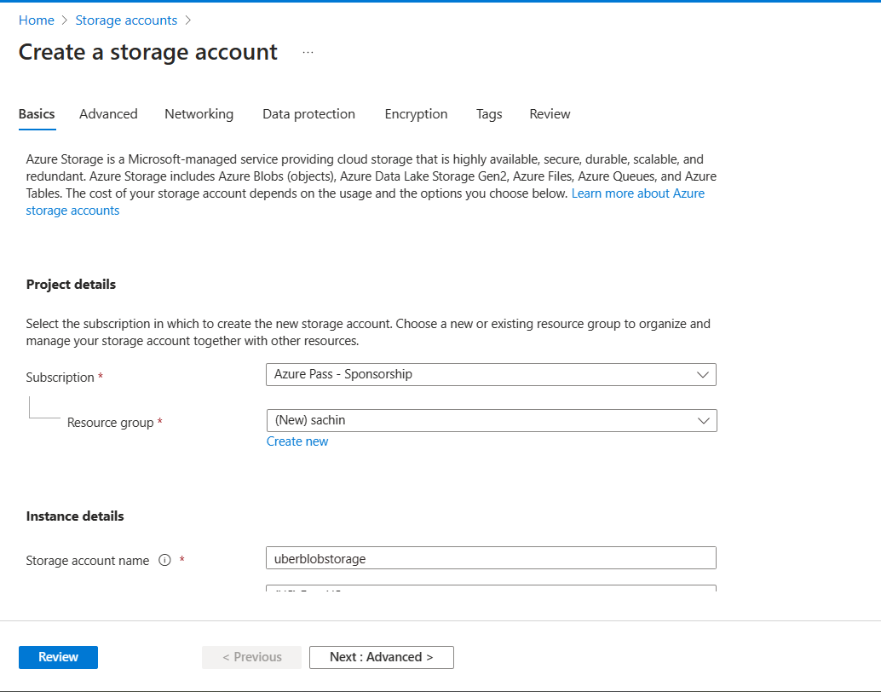

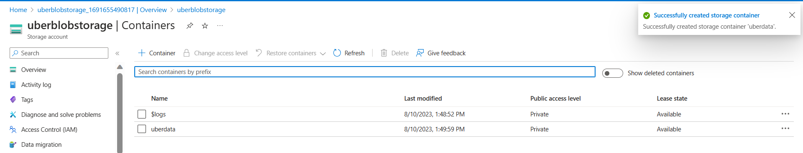

STEP 2: Putting Uber dataset file in the container in the azure storage

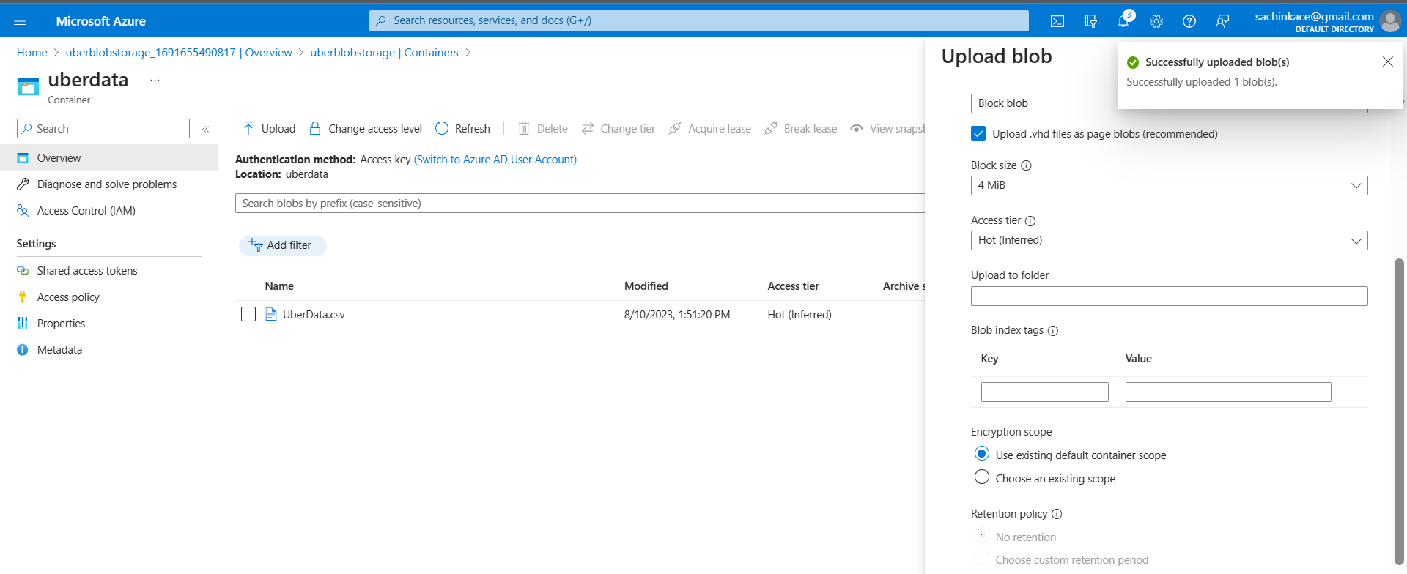

IN SNOWFLAKE:

1. Create a datawarehouse

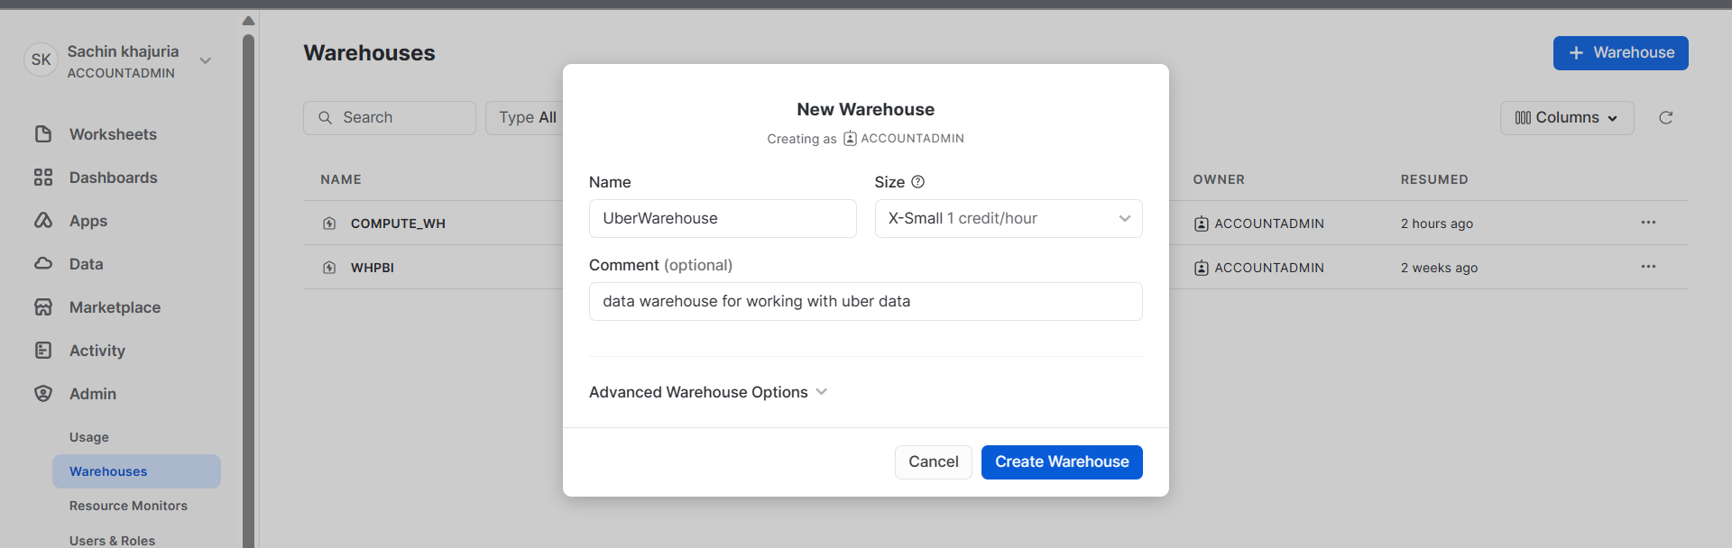

1. Create a Schema
2. Create a database
3. Create the table schema which we are transferring our data into

Doing 2,3,4 in SnowSQL CLI:

-Opening SnowSQL CLI

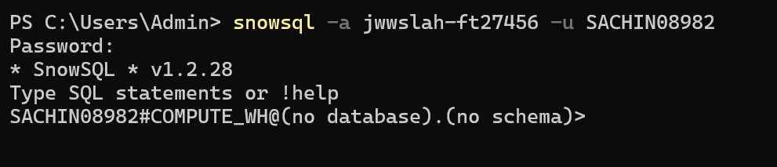

-Creating database and using it

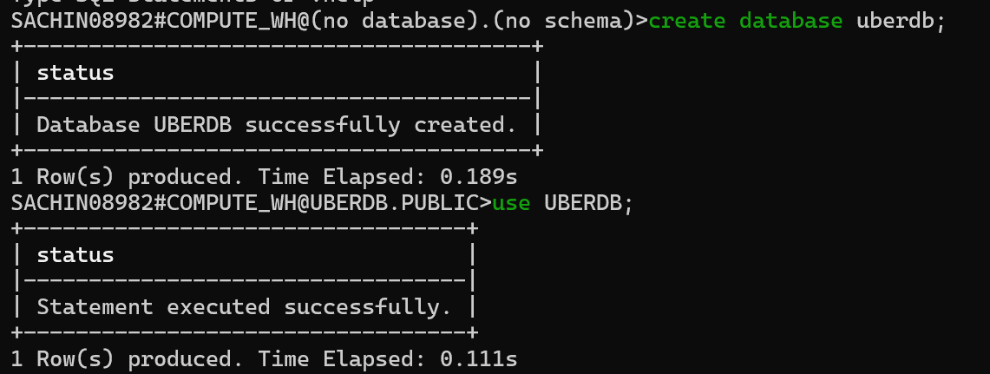

-creating Schema and using it:

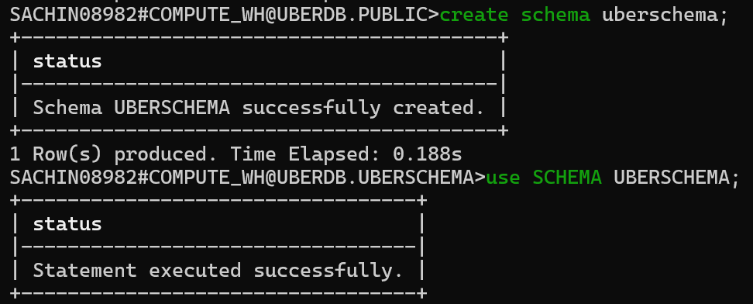

-using our warehouse:

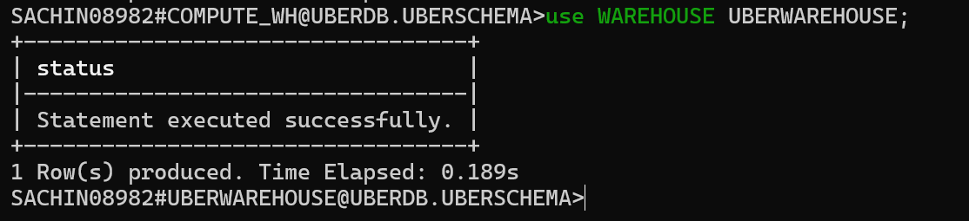

-creating table

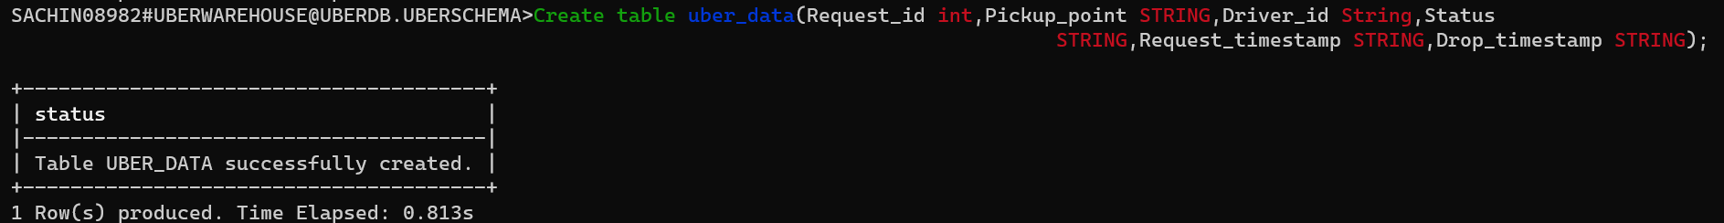

STEP 3: Creating File format

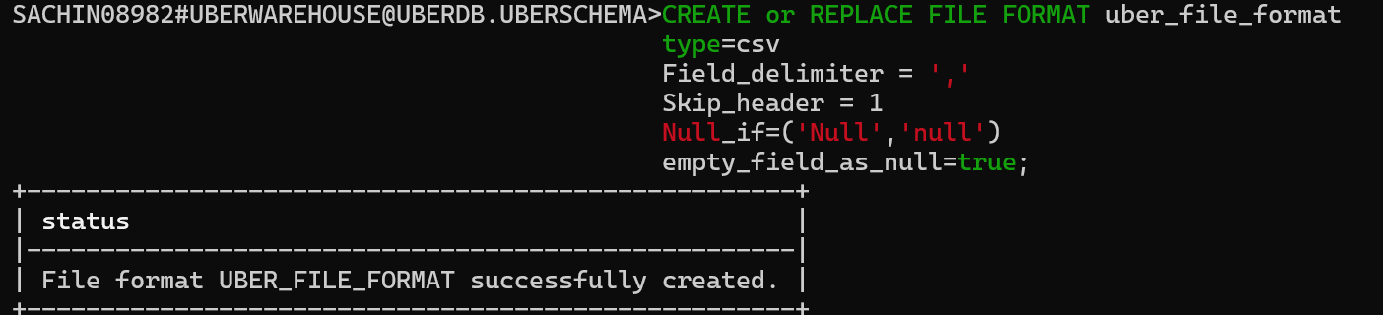

STEP 4: Creating external stage

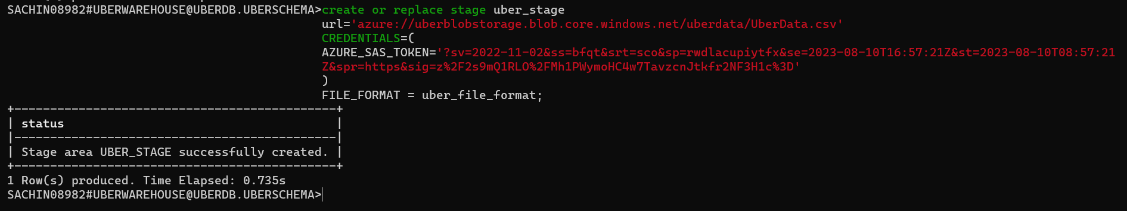

Getting Storage URL:

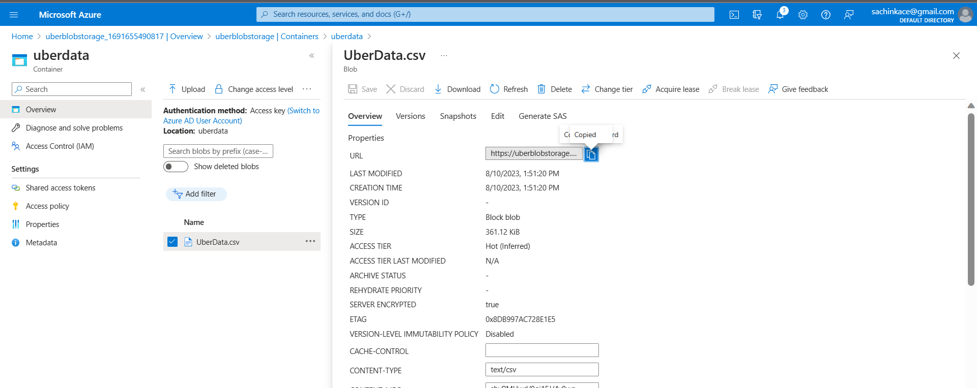

getting AZURE SAS TOKEN:

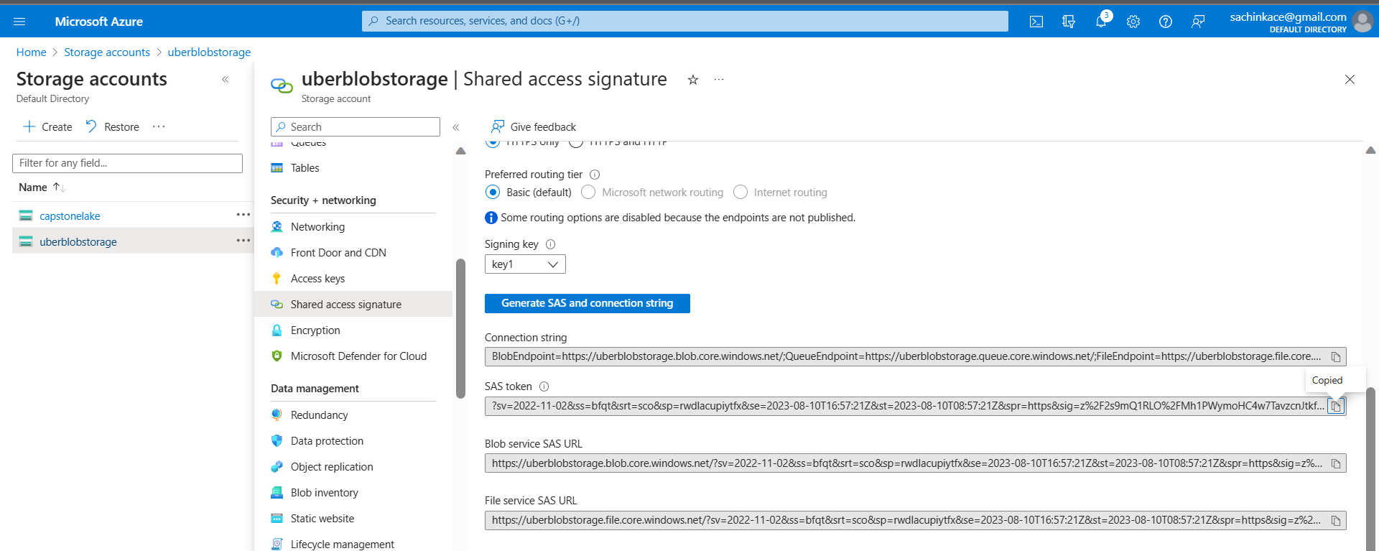

-Running copy into to push data from external stage to the table we created

